**BLG312E – Operating Systems, Spring 2021**

**Assignment 1**

**Abdulkadir Pazar – 150180028**

8 processes will be created by the code. 1 process is parent and there are 7 children processes.

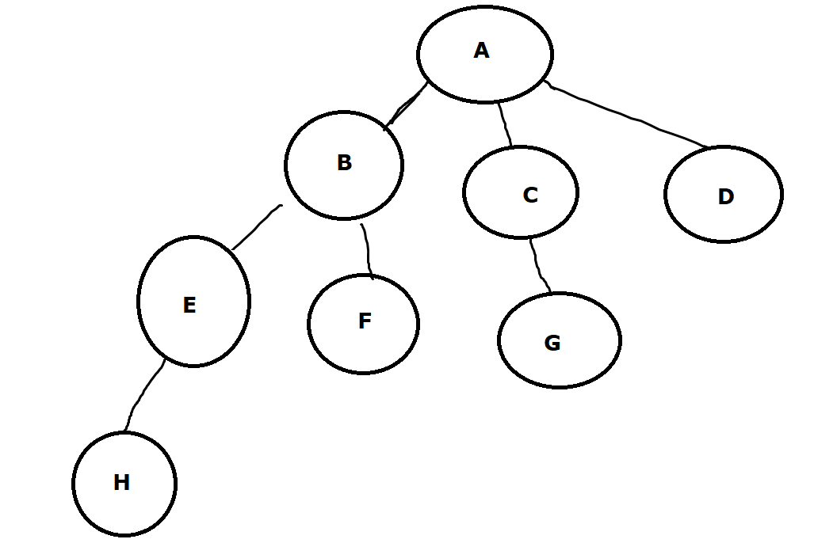

Tree created by the program

fork() system call will be invoked 7 times as there are 7 child processes. printf() function will be invoked 14 times, twice per process. In general fork will be invoked 2n-1 times and printf will be invoked 2n+1 – 2 where n is the number in the loop condition i <= n.

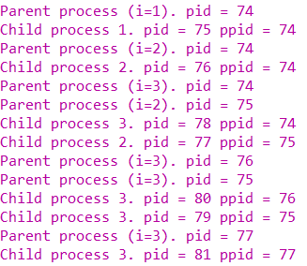 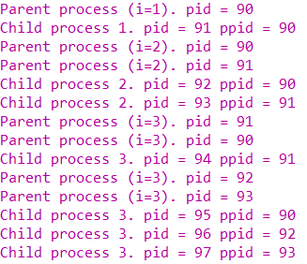

Two different outputs of the program

The program outputs cannot be predicted as the time a process will have the processor cannot be predicted since the processor will run a different process every time there is a context switch. The diagram below is helpful to visualize why the output cannot be predicted as the processes are represented as rounded rectangles and if the order of the boxes changes the output the program prints to the console changes.

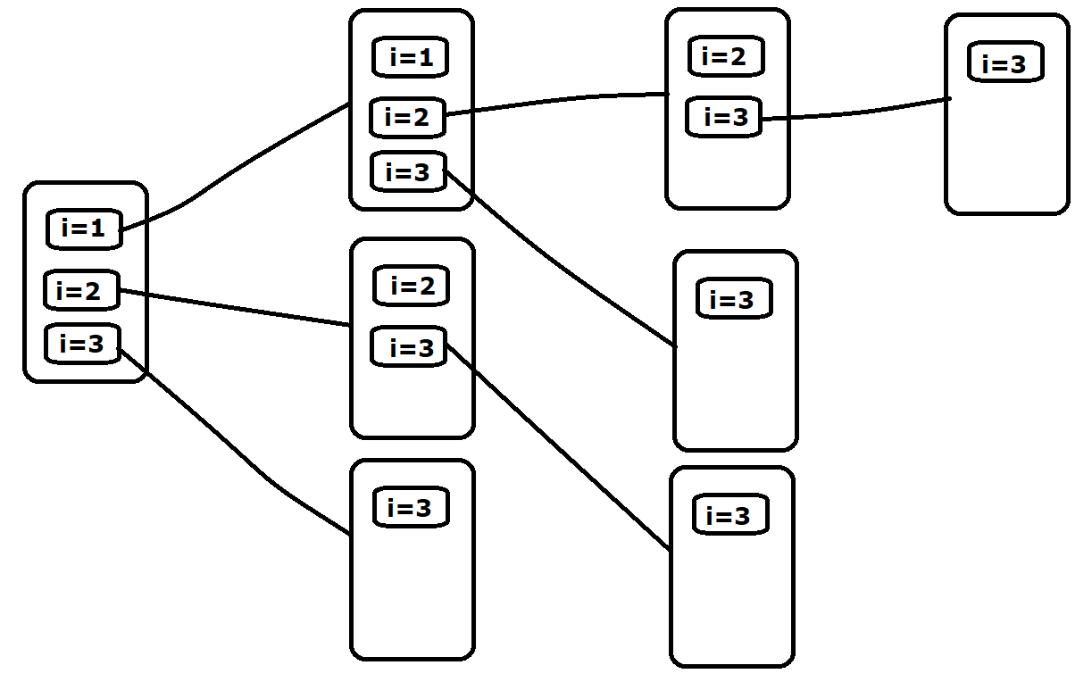

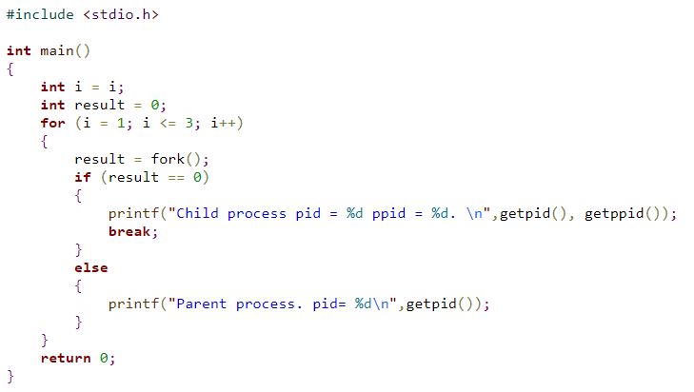

The code above will create 3 child processes which have the same parent process.